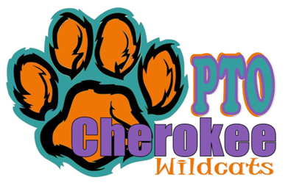
Minutes
Cherokee PTO
General PTO Meeting
Date | time 10/10/2023/6:19 pm | Meeting called to order by Julianna Kozinski

In Attendance
Julianna Kozinski, Angela Drost, Nicole Tomaszyski, Monica Radyko, Caren Melton, Jamie White, Rachel Maikvzek, Meghan Brown, Crystal Kozak, Cindy Bestard, Latice Smith,

Walk-A-Thon
- Julianna began the meeting with a discussion about Walk-A-Thon
- The winners for Walk-A-Thon have not been announced yet.
- There will be prizes for the top three classes.
- There will be prizes for the top families and students.
- The Walk-A-Thon raised $18,430.
- The day went well, and the weather was perfect.
- All prizes have been passed out.

Trunk or Treat
- Crystal discussed trunk or treat.
- Flyers went out with event details.
- Sign-Up Genius to sign up to decorate a trunk.
- Thirteen cars signed up.
- Sign-Up Genius to sign up for trunk or treat.
- Thirty-five students registered.
- Candy provided by the PTO.
- The time on the event flyers needs to be changed to 6:30-8:30 pm.
- Need to make copies of the flyer to send out to families.

Santa Shop
- Santa Shop will take place November 28-December 1 (Monday is set up day)
- A Sign-Up Genius will be posted at the end of the month.
- Angela called FunServices and is waiting on a return phone call.
- We will need volunteers to sign up for gift wrapping and helping students shop.
- We need to find out if the treasurer needs to be at Santa Shop the whole time.

Holiday Event
- The holiday party will take place on December 15, 2023.
- Monica asked if we could up the $1000 budget for this event.
- We need to find out prices for Santa and book him.
- We will need volunteers the day of the event for decorating. We may need volunteers the night before to help with decorations.

Fundraiser
- Sock fundraiser did not really make any money.
- The PTO purchased the socks in bulk and sold them. There were also online sales.
- There was a decent amount sold online.
- Should socks be sold at events?
- We need to decide when to do sock order again.
- We can investigate doing different colors. Possibly matching grade level shirts.
- Could we give the socks as prizes?
- Staff and student’s shirts were over $5000.
- The PTO is paying for the school to see the musical at Chippewa Valley. It will cost around $6000.
- Panera restaurant night brought in $200.
- There is a Gym Jam scheduled for November 11th. Flyer will be coming out soon. Parents can drop of their child.
- Nothing Bundt Cakes will start beginning of November. The cakes will be picked up on the 20th.

Budget
- Nicole handed out a copy of the budget for the 2023-2024 school year.
- Have not received the check for the restaurant night at Panera.
- Restitution money, there is about $30,000. We can use this money for different things at the school, but it must reach all students. Examples, kindergarten playground, outdoor classroom

Other
- “Paws Pals” looking for volunteers. Sign-Up Genius is posted in the smores. (Lunch Program)
- Kelly is looking into places for the daddy/daughter dance. Looking into Fernhill or Shelby Gardens.
- Meeting ended at 7:14 pm.

Click or tap here to enter text.

