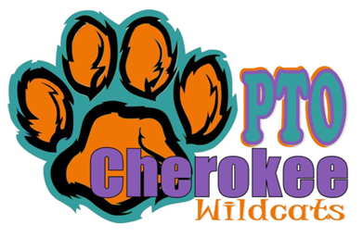
Minutes
Cherokee PTO
Board PTO Meeting
Date | time 11/06/2023/6:05 pm | Meeting called to order by Julianna Kozinski

In Attendance
Julianna Kozinski, Angela Drost, Monica Radyko, Caren Melton, Jamie White, Rachel Maikvzek, Meghan Brown, Crystal Kozak, Amber Kincher,

Walk-A-Thon
- Julianna began the meeting with a discussion about Walk-A-Thon
- The winners for Walk-A-Thon have not been announced yet.
- There will be prizes for the top three classes.
- There will be prizes for the top families and students.
- The Walk-A-Thon raised $18,430.
- The day went well, and the weather was perfect.
- All prizes have been passed out.

Trunk or Treat
- Crystal discussed trunk or treat.
- Flyers went out with event details.
- Sign-Up Genius to sign up to decorate a trunk.
- Thirteen cars signed up.
- Sign-Up Genius to sign up for trunk or treat.
- Thirty-five students registered.
- Candy provided by the PTO.
- The time on the event flyers needs to be changed to 6:30-8:30 pm.
- Need to make copies of the flyer to send out to families.

Santa Shop
- Santa Shop will take place November 28-December 1 (Monday is set up day)
- A Sign-Up Genius will be posted at the end of the month.
- Angela called FunServices and is waiting on a return phone call.
- We will need volunteers to sign up for gift wrapping and helping students shop.
- We need to find out if the treasurer needs to be at Santa Shop the whole time.

Holiday Event
- The holiday party will take place on December 15, 2023.
- Monica asked if we could up the $1000 budget for this event.
- We need to find out prices for Santa and book him.
- We will need volunteers the day of the event for decorating. We may need volunteers the night before to help with decorations.

Fundraiser
- Sock fundraiser did not really make any money.
- The PTO purchased the socks in bulk and sold them. There were also online sales.
- There was a decent amount sold online.
- Should socks be sold at events?
- We need to decide when to do sock order again.
- We can investigate doing different colors. Possibly matching grade level shirts.
- Could we give the socks as prizes?
- Staff and student’s shirts were over $5000.
- The PTO is paying for the school to see the musical at Chippewa Valley. It will cost around $6000.
- Panera restaurant night brought in $200.
- There is a Gym Jam scheduled for November 11th. Flyer will be coming out soon. Parents can drop of their child.
- Nothing Bundt Cakes will start beginning of November. The cakes will be picked up on the 20th.

Budget
- Nicole handed out a copy of the budget for the 2023-2024 school year.
- Have not received the check for the restaurant night at Panera.
- Restitution money, there is about $30,000. We can use this money for different things at the school, but it must reach all students. Examples, kindergarten playground, outdoor classroom

Other
- “Paws Pals” looking for volunteers. Sign-Up Genius is posted in the smores. (Lunch Program)
- Kelly is looking into places for the daddy/daughter dance. Looking into Fernhill or Shelby Gardens.
- Meeting ended at 7:14 pm.

Click or tap here to enter text.

