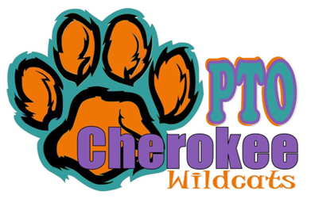
Minutes
Cherokee PTO
Date | time 5/30/2023/6:35 p.m. | Meeting called to order by Julianna Kozinski • Juliana led a discussion about the by-laws, which cannot be changed, during an election meeting. • There are several by-laws that are not in line with how the Cherokee PTO operates.• Plan to update/vote on updating by-laws at the first meeting of next school year.

In Attendance
Julianna Kozinski, Angela Drost, Megan Brown, Nicole Tomaszyski, LaShuna Early, Monica Radyko, Caren Melton, Kathy Fontaine, Jamie White, Jason Bestard, Kelly Farmer, Rachel Maikvzek, Amber Kincher, Michelle Aiello, Heather Batko

Introductions
- Attendees introduced themselves; stating their name, student(s) name and grade level, board members stated their positions.

Discussion of Bylaws
- Julianna led a discussion about the by-laws, which cannot be changed, during an election meeting. There are several by-laws that are not in line with how the Cherokee PTO operates. Plan to update/vote on updating by-laws at the first meeting of next school year.

Discussion of Board Positions and Voting
- Board positions and those running for each position were announced.
- Voting open at 6:48
- The vote was done verbally.
- All votes were in favor.
  - Julianna Kozinski - President
  - Angela Drost – Vice President
  - Nicole Tomaszyski - Treasurer
  - Monica Radyko – Secretary
  - LaShuna Early, Kathy Fontaine, Caren Melton, Rachel Maikvzek, Jamie White, Kelly Farmer, Crystal Kozak and Amber Kincher – Coordinator(s)/Representatives
- Vote closed at 6:50

Welcome Back Event
- The event will be held on Tuesday, August 29th.The theme for 2023 - 2024 school year will be superheroes. There will be selfie stations, popsicles and more.

Next Meeting
A PTO board recap meeting will be held before the end of year to discuss how events went this year and changes for the upcoming year.
The meeting was adjourned at 7:43 p.m.

